9 SCIENCE 2016

PHYSICS TEST ONE

Name: ____________________ Teacher: ___________________ Mark: /49

Percentage: %

SECTION A: MULTIPLE CHOICE (20 marks)

Select the most correct answer for each question below.

1. A B C D 11. A B C D
2. A B C D 12. A B C D
3. A B C D 13. A B C D
4. A B C D 14. A B C D
5. A B C D 15. A B C D
6. A B C D 16. A B C D

7. A B C D 17. A B C D

8. A B C D 18. A B C D

9. A B C D 19. A B C D

10. A B C D 20. A B C D

1. Letter A in the diagram below represents:
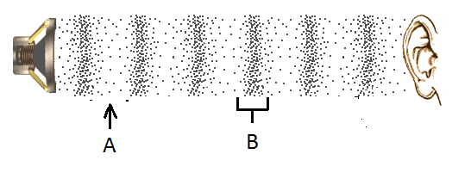

(a) Compression.
(b) Sound wave.
(c) Refraction.
(d) Rarefaction.

2. Choose the correct definition for ‘frequency’.

(a) Closely packed particles vibrating in a region.
(b) The number of waves passing a point every second.
(c) The distance from one peak of a wave to the next.
(d) The number of waves passing a point every minute.

3. Sound travels the fastest through:

(a) Gas.
(b) Steam.
(c) Liquid.
(d) Solid.

4. Choose the correct definition for ‘conduction’.

(a) Transfer of heat in a liquid or gas due to less dense, warmer matter rising and denser, cooler matter falling.
(b) A method of heat transfer where heat is passed through the vibration of particles.
(c) Movement of heat in the form of electromagnetic waves.
(d) A substance that allows heat to pass through it.

5. Choose the correct definition for ‘heat’.

(a) A form of energy that describes the total movement of all particles within an object.
(b) The measure of how quickly the particles in a material are moving.
(c) The average kinetic energy of particles in a material.
(d) A method of heat transfer.

6. Choose the correct statement about sea breezes.

(a) Air cools and drops down on the land from over the ocean.
(b) A sea breeze occurs during the day.
(c) Warm air rises up from over the ocean.
(d) A sea breeze occurs at night.

7. Choose the correct definition for ‘radiation’.

(a) Movement of heat by electromagnetic waves.
(b) A material that does not conduct heat.
(c) A method of heat transfer where heat is passed through the vibration of particles.
(d) Transfer of heat in a liquid or gas due to less dense, warmer matter rising and denser, cooler matter falling.

8. Choose the correct definition for ‘temperature’.

(a) A measure of the average kinetic energy of particles in a substance.
(b) An instrument used to measure temperature.
(c) A measure of the average potential energy of particles in a substance.
(d) A measure of the heat in a substance.

9. Choose the correct definition for ‘wavelength’.

(a) The number of waves passing a point every second.
(b) The sensation of frequency.
(c) The distance from one peak of a wave to the next.
(d) The number of hertz in a wave.

10. The length of time a sound is heard is known as:

(a) Reverberation.
(b) Echo.
(c) Vibration.
(d) Frequency.

11. Choose the material that would have the slowest speed of sound.

(a) Steel.
(b) Air (at 0°C).
(c) Water.
(d) Glass.

12. Select the ending for the following sentence. Soft materials:

(a) Reflect sound.
(b) Absorb sound.
(c) Transmit sound.
(d) Increase echo in a room.

13. Choose the correct function of the ossicles.

(a) Three tiny bones that transmit vibrations to the cochlear.
(b) Filled with fluid and gives us our sense of balance.
(c) Has hairs to trap dust and dirt.
(d) Funnels sound into the ear canal.

14. Choose the correct function of the semicircular canals.

(a) Carries electrical impulses to the brain.
(b) Filled with fluid, has hairs that pick up vibrations and converts them into electrical impulses.
(c) Filled with fluid and gives us our sense of balance.
(d) Funnels sound into the ear canal.

15. Choose the correct function of the cochlea.

(a) Has hairs to trap dust and dirt.
(b) Carries electrical impulses to the brain.
(c) Filled with fluid, has hairs that pick up vibrations and converts them into electrical impulses.
(d) Three tiny bones that magnify vibrations.

16. When light hits a material and almost all light is transmitted through the substance and a clear image can be seen through, this material is called:

(a) Clear.
(b) Opaque.
(c) Translucent.
(d) Transparent.

17. Select the object that is luminous.

(a) A bicycle reflector.
(b) The planet Venus.
(c) The star Betelgeuse.
(d) A mirror.

18. The Law of Reflection:

(a) States that when a ray of light is reflected from a smooth surface, the angle of reflection is equal to the angle of incidence.
(b) States that when a ray of heat is reflected from a smooth surface, the angle of reflection is equal to the angle of incidence.
(c) States that when a ray of light is reflected from a rough surface, the angle of reflection is equal to the angle of incidence.
(d) States that when a ray of light is reflected from a smooth surface, the angle of reflection is more than the angle of incidence.

19. An imaginary dotted line at right angles to the surface used to measure the angle of incidence and the angle of reflection is called:

(a) The straight line.
(b) The equal line.
(c) The normal ray.
(d) The straight ray.

20. Light is a form of energy called:

(a) Electromagnetic radiation.
(b) Electro energy.
(c) Electronmagnetic radiation.
(d) Wave energy.

SECTION B: SHORT ANSWER (29 marks)

1. Label the diagram of the ear below. (8 marks)
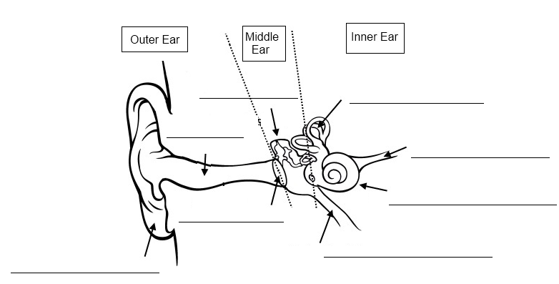

2. Fill in the table below. (3 marks)
Beryllium

Part of ear | Function
Cochlea | _______________________________________________________________________  _______________________________________________________________________
Eustachian  tube | _______________________________________________________________________  _______________________________________________________________________
Auditory  nerve | _______________________________________________________________________  _______________________________________________________________________
3. List the three ways that heat can be transferred (moved). (3 marks)

_____________________________________________________________________________________

_____________________________________________________________________________________

4. State the name of an animal that uses ultrasounds. (1 mark)

_____________________________________________________________________________________

5. State the name of an animal that uses infrasounds. (1 mark)

_____________________________________________________________________________________

6. Classify the following objects as transparent, translucent or opaque. (4 marks)

a) A basketball: ________________________________

b) Air: ________________________________

c) A pair of sheer stockings: _________________________________

d) A piece of lightweight cotton fabric: _________________________________

7. Describe one difference between regular reflection and diffuse reflection. (2 marks)

_____________________________________________________________________________________

_____________________________________________________________________________________

_____________________________________________________________________________________

_____________________________________________________________________________________

8. Label one wavelength on the diagram below. (1 mark)

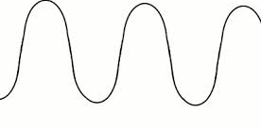

9. Draw a labelled diagram that shows how convection works in a pot of boiling water.
(4 marks)

10. State the unit used to measure frequency. (1 mark)

_____________________________________________________________________________________

11. What is the type of wave demonstrated in the diagram below? (1 mark)

_____________________________________________________________________________________
